**CP Club 365 Days Challenge**

**Programming language – C++**

**Problem Statement**

<https://www.codechef.com/DSAPREP_01/problems/LUCNUM>

**Your Code**:

// 0x78Day of 0x365Days challenge

// VEDANT BHARAD

// 3-1-2023

#include <bits/stdc++.h>

using namespace std;

int main() {

    int t;

    cin>>t;

    while(t--){

            long long x;

            cin>>x;

            int temp=0;

            while(x%2==0){

                x/=2;

                temp++;

            }

            if(temp%2==0)

                cout<<"1"<<endl;

            else

                cout<<"0"<<endl;

    }

    return 0;

}

**Output (Screen Shot)**:

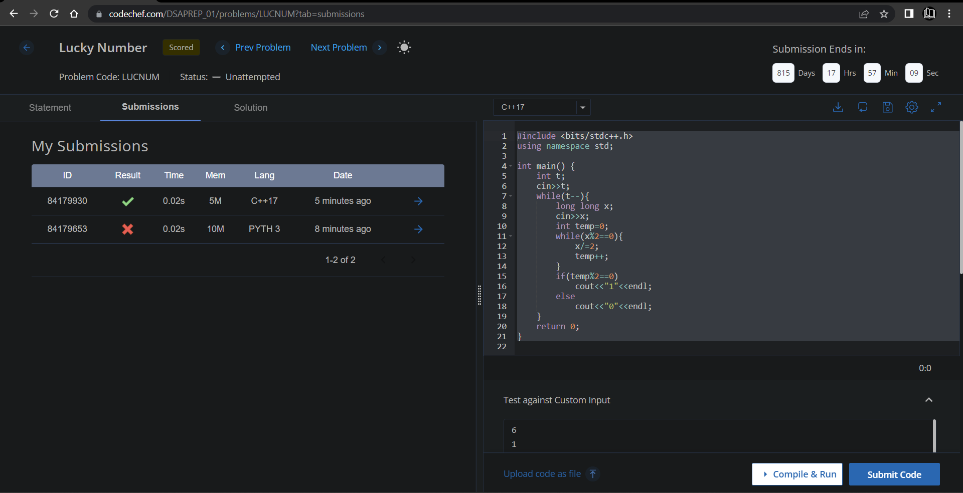

**Understanding about problem:**

* In this task I need to return 0 or 1 based on one logic prime factorization, if it has an even power of 2 in prime factorization then return 1 else return 0.

Note: If you can't understand the problem, feel free to contact us and we'll help you. Please don't copy and paste from anywhere.

ALL THE BEST

Team CP Club